SALES QUOTATION – RR_21.22_0135

VSSC/ISRO. Date – 15/12/2021
Project – Trivandrum
Product – Moving Shelter-Test Bed

Thank you for your opportunity and trust shown on “NIHVA” your preferred partner for innovative solutions. This has reference to your above-mentioned requirement, please find below our Solutions.
Operational Technique
The whole framework is made of SS 304 grade. The system is made of single panel that is going to slide with the help of the guide laid along the length of the system. The motor and electrical system are going to be mounted on the moving shelter. It is going to move over the 3-Test Bed that are present on the site. The system does not depend on cables, hydraulic, pneumatic etc. It only works on battery operated electrical system with all logic defined as per the system requirement.

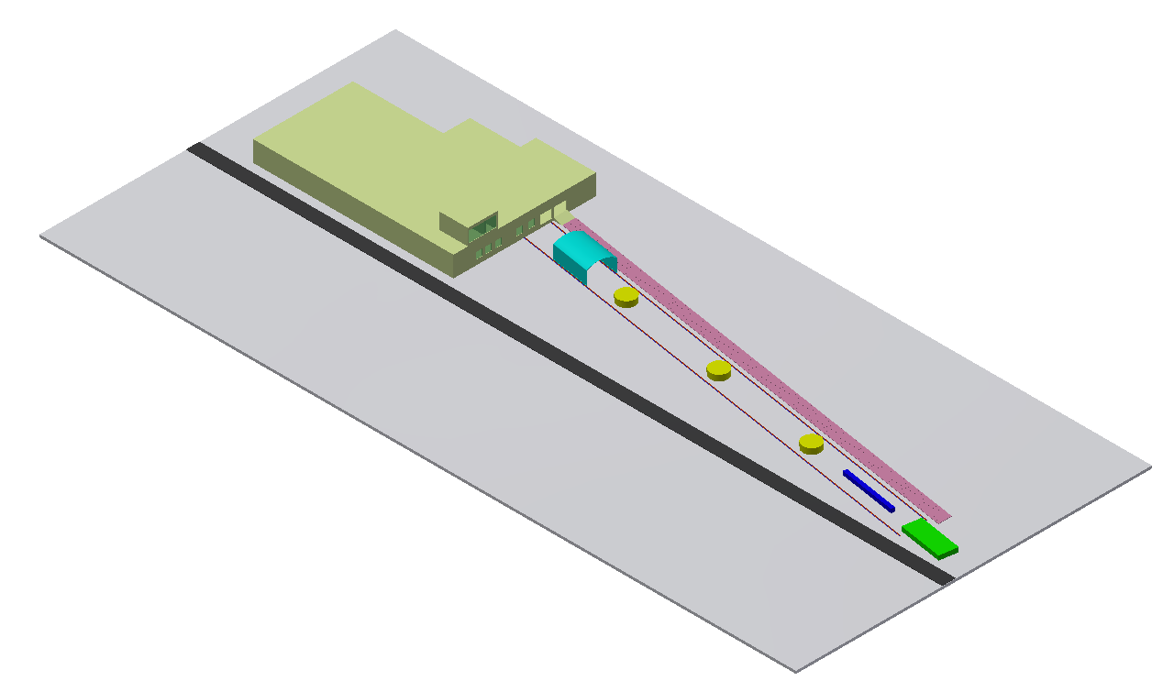

Scope of work

- Design, Manufacturing, Supply, Installation, Commissioning and Service of battery-operated Moving shelter for Test Bed.

Technical Functionality

We’re proposing two options.
1. Battery-operated Moving shelter (Without Certification)
2. ATEX certified battery-operated Moving shelter

In Option 1, the battery-operated moving shelter structure is made up of SS 304 of dimension 6m(W) X 10m (L) X 4.5m(H). The system moves on brushless drive with the speed of 1.5kmph for the required distance of 125m approx. The whole system slides along the length with intermediate Test Bed Station with the help of battery-operated motor mechanism. The system can be operated by hand remote.

In Option 2, the moving shelter structure is made up of SS 304 of dimension 6m(W) X 10m (L) X 4.5m(H). The battery-operated mechanism is certified as category 3G IIB T3 in conformity with ATEX 2014/34/EU. It is an explosion proof system with a battery autonomy of approximately 90hrs. The explosion version has a specific design in safety features concerning the electrical parts (batteries, connectors, sensors, control unit etc.) and non-electric parts that could generate high temperatures and sparks (mechanical parts, breaks etc.).
The option 2 comes with inbuilt over heating sensor which checks the surface temperature according to the class. If the temperature increases, the system will automatically shut down.
The non-electrical parts are equipped with wear & temperature sensor to avoid the formation of sparks caused by friction between the metals.

The shop drawings along with tech specs will be submitted for approval after receipt of confirm P.O.

Commercial Details

Sr. No. | Description | QTY | SUPPLY PRICE | INSTALLATION PRICE | TOTAL SUPPLY & INSTALLATION
Option 1 | Battery-operated Moving shelter (Without Certification)  6m(W) X 10m (L) X 4.5m(H) | 1 | ₹ 1,74,00,000 | ₹ 7,50,000 | ₹ 1,81,50,000
Option 2 | ATEX certified battery-operated Moving shelter  6m(W) X 10m (L) X 4.5m(H) | 1 | ₹ 2,85,00,000 | ₹ 7,50,000 | ₹ 2,92,50,000
P& F Charges | 3% |  |  |  | Extra at Actual
GST | 18% |  |  |  | Extra at actual
Excluding Transportation + Unloading material at site + Lifting Equipment if any
General Terms & Conditions
  - NIHVA is going to use external structural consultant for structural stability.
  - Make and Model of electrical components would be finalized with the consent of client’s site team from the suggestion provide by NIHVA team.
  - Multiple site visit will be going to carried out at different stages of project by NIHVA.
  - WBS to be submitted by NIHVA after receival of PO.
  - Continuous uninterrupted access to installation section or as agreed separately.
  - Provision of 230 Volt power supply (by others) for hand tools.
  - A dry and secure area, not in direct sunlight, is to be provided for storage of the product components.
  - Access to site between 7 am to 12 pm six days per week. If this is not possible, the installation programme may require amending.
  - Any storage costs for materials due to delays outside of NIHVA, will be in Client Scope.
  - Unloading of material and internal movement of material on site to the installation area is under Client scope.
  - The project time indicated does not take into account adverse weather conditions, pandemic situation, local Govt restrictions that may prevent safe and efficient working practices. We reserve the right to extend the period accordingly.
  - Any passes required for the project, are the responsibility of the Customer and Contractor and must be available, before commencement of the installation. Any delays caused by the non-availability of passes, will be charged accordingly.
Sr. No | Remark
1 | Secured and fully covered Store area to keep the material | In Client Scope
2 | Scaffolding/Hydra/Crane/Forklift etc - Required for Installation at Site | In Client Scope
3 | Electrical Supply on the site single phase/three phase points at different places. | In Client Scope
4 | Any civil / masonry/structural work required | In Client Scope
5 | All structure support required | In Client Scope
6 | In Case of any changes in the layout as per site requirements after the shipment of material, the additional quantities and the wastage. | In Client Scope
7 | Conduits, Cables required | In Client Scope

Terms & Conditions

Price: Ex Works Pune
Delivery: Approximately 15-16 weeks from having received official order confirmation + advance payment + signed & stamp drawing approval
(Subject to - Lead time might be impacted due to current crisis of Covid -19)
Supply Payment:
60% Advance along with confirmed Purchase order on Supply price
35% before dispatch of material
5% after completion of installation
Installation Payment:
50% of Installation charges before mobilization of team
50% of Installation charges after Installation, commissioning & testing
Validity: Validity of Offer is 15 days from the date of quotation
Warranty: Warranty from date of supply -
1 Years for manufacturing defect on the structural system
1 Year on Mechanical drive system and for all electrical components
AMC: 8.5% of the product value for each year till the time period of 3 years
Revision of AMC value applicable after completion of 3 years
Design Clause
NIHVA shall be deemed the authors of their respective concept and drawings with reserved rights, including copyrights. It shall not be used by the owner for future additions or alterations to this project or for another project or should not copied at any other future project or should not transfer or copied by anyone.
Compensation Clause
Please note that in the event the buyer cancels an order, after the order is confirmed to us, it is binding to the buyer to pay NIHVA a compensation of 25% of order value.

Please feel free to Contact us for any further Clarification Information in this Concern.

With Best Regards,
Vijay Tarak
+91-85510 33333
NIHVA Technologies Pvt Ltd.

